|  |
| --- |
|  |

|  |
| --- |
| **Stock Chart Patterns** |
| Semantics |
|  |
| This document include basic stock chart patterns and description on its behavior and the concept behind the patterns. |
|  |
| **ARCANE** |
| **7/25/2014** |
|  |

Table of Contents

5 Great Stock Chart Patterns 3

Gaps 3

A. First 3

B. Second 4

Head and shoulders 10

A. First 10

B. Second 10

Triple bottom/top 17

A. First 17

B. Second 18

Double bottom/top 21

A. First 21

B. Second 22

Saucers 25

Symmetrical Triangle – Symmetrical Triangle Pattern 26

A. First 26

B. Second 28

Ascending Triangle – Ascending Triangle Pattern 29

A. First 29

B. Second 31

Descending Triangle – Descending Triangle Pattern 32

A. First 32

B. Second 34

Cup and Handle Pattern 35

A. First 35

B. Second 37

Bull Flag – Bull Flag Pattern 39

A. First 40

B. Second 41

Bear Flag – Bear Flag Pattern 42

Bull Pennant – Bull Pennant Pattern 44

A. First 44

B. Second 46

Bear Pennant – Bear Pennant Pattern 47

Descending Channel – Descending Channel Pattern 49

Ascending Channel – Rising Channel 51

Rectangle Pattern 53

Wedge chart pattern 55

References 57

## 5 Great Stock Chart Patterns

## **Gaps**

### First

Gaps occur when a price opens much higher (gap higher) or lower (gap lower) than the previous day’s close. Once a gap occurs, the new price represents an important price level. Gaps higher create support that should allow the stock to move higher and gaps lower create resistance that should pressure the stock lower. Until the gap is violated, we should assume the trend will continue in the gap’s direction. Amazon.com (AMZN) shows a gap higher on heavy volume (black arrow) that now acts as support (black line). As the stock has traded higher from that moment, it would take a close below $57.50 to indicate the bullish move is over.

[[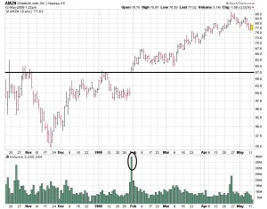](http://www.stocktradingtogo.com/wp-content/uploads/2009/05/amzn-gap.jpg?a7518c)Click to Enlarge](http://www.stocktradingtogo.com/wp-content/uploads/2009/05/amzn-gap.jpg?a7518c)

### Second

A [gap](http://www.investopedia.com/terms/g/gap.asp) in a chart is essentially an empty space between one trading period and the previous trading period. They usually form because of an important and material event that affects the security, such as an earnings surprise or a merger agreement.   
  
This happens when there is a large-enough difference in the opening price of a trading period where that price and the subsequent price moves do not fall within the range of the previous trading period. For example, if the price of a company's stock is trading near $40 and the next trading period opens at $45, there would be a large gap up on the chart between these two periods, as shown by the figure below. 

|  |
| --- |
| http://i.investopedia.com/inv/articles/site/Gap.gif |
| Figure 1 |

Gap price movements can be found on [bar charts](http://www.investopedia.com/terms/b/barchart.asp) and [candlestick](http://www.investopedia.com/terms/c/candlestick.asp) charts but will not be found on [point-and-figure](http://www.investopedia.com/terms/p/pointandfigurechart.asp) or [basic line charts](http://www.investopedia.com/terms/l/linechart.asp). The reason for this is that every point on both point-and-figure charts and line charts are connected.   
  
It is often said when referring to gaps that they will always fill, meaning that the price will move back and cover at least the empty trading range. However, before you enter a trade that profits the covering, note that this doesn't always happen and can often take some time to fill.   
  
There are four main types of gaps: [common](http://www.investopedia.com/terms/c/commongap.asp), [breakaway](http://www.investopedia.com/terms/b/breakawaygap.asp), [runaway](http://www.investopedia.com/terms/r/runawaygap.asp) (measuring), and[exhaustion](http://www.investopedia.com/terms/e/exhaustiongap.asp). Each are the same in structure, differing only in their location in the trend and subsequent meaning for chartists.   
  
**Common Gap**As its name implies, the common gap occurs often in the price movements of a security. For this reason, it's not as important as the other gap movements but is still worth noting. 

|  |
| --- |
| http://i.investopedia.com/inv/articles/site/CommonGap.gif |
| Figure 2: Common Gap |

These types of gaps often occur when a security is trading in a range and will often be small in terms of the gap's price movement. They can be a result of commonly occurring events, such as low-volume trading days or after an announcement of a stock split.

These gaps often fill quickly, moving back to the pre-gap price range.   
  
**Breakaway Gap**A breakaway gap occurs at the beginning of a market move - usually after the security has traded in a consolidation pattern, which happens when the price is non-trending within a bounded range. It is referred to as a breakaway gap as the gap moves the security out of a non-trending pattern into a trending pattern. 

|  |
| --- |
| http://i.investopedia.com/inv/articles/site/BreakawayGap.gif |
| Figure 3: Breakaway gap |

A strong breakaway gap out of a period of consolidation is considered to be much stronger than a non-gap move out. The gap gives an indication of a large increase in sentiment in the direction of the gap, which will likely last for some time, leading to an extended move.   
  
The strength of this gap (and the accuracy of its signal) can be confirmed by looking at that volume during the gap. The greater the volume out of the gap, the more likely the security will continue in the direction of the gap, also reducing the chances of it being filled.   
  
While the breakaway gap generally doesn't fill like the common gap, it will in some cases. The gap will often provide support or resistance for the resulting move. For an upward breakaway gap, the lowest point of the second candlestick provides support. A downward breakaway gap provides resistance for a move back up at the highest price in the second candlestick.   
  
The breakaway gap is a good sign that the new trend has started.   
  
**Runaway Gap (Measuring Gap)**A runaway gap is found around the middle of a trend, usually after the price has already made a strong move. It is a healthy sign that the current trend will continue as it indicates continued, and even increasing, interest in the security. 

|  |
| --- |
| http://i.investopedia.com/inv/articles/site/Runaway.gif |
| Figure 4: Runaway (or measuring) gap |

After a security has made a strong move, many of the traders that have been on the sideline waiting for a better entry or exit point decide that it may not be coming and if they wait any longer they will miss the trade. It is this increased buying or selling that creates the runaway gap and continuation of the trend.   
  
Volume in a runaway gap is not as important as it is for a breakaway gap but generally should be marked with average volume. If the volume is too extreme, it could signal that the runaway gap is actually an exhaustion gap (discussed further in the next section), which signals the end of a trend.   
  
The runaway gap forms support or resistance in the exact same manner as the breakaway gap. Likewise, the measuring gap does not often fill, and there's cause for concern if the price breaks through the support or resistance, as it is a sign that the trend is weakening - and could even signal that this is an exhaustion gap and not a runaway gap.   
  
**Exhaustion Gap**This is the last gap that forms at the end of a trend and is a negative sign that the trend is about to reverse. This usually occurs at the last thrusts of a trend (typically marked with panic or hype), but can also be the point when weaker market participants start to move in or out of the security.   
  
The exhaustion gap usually coincides with an irrational market philosophy, such as the security being touted as "a can't-miss opportunity" or conversely as something to "avoid at all costs". 

|  |
| --- |
| http://i.investopedia.com/inv/articles/site/exhaustiongap.gif |
| Figure 5: Exhaustion gap |

To identify this as an exhaustion gap or the last large move in the trend, the gap should be marked with a large amount of volume. The strength of this signal is also increased when it occurs after the security has already made a substantial move.   
  
  
  
Because the exhaustion gap signals a trend reversal, the gap is expected to fill. After the exhaustion gap, the price will often move sideways before eventually moving against the prior trend. Once the price fills the gap, the pattern is considered to be complete and signals that the trend will reverse.   
  
**Island Reversal**One of the most well-known gap patterns is the [island reversal](http://www.investopedia.com/terms/i/islandreversal.asp), which is formed by a gap followed by flat trading and then confirmed by another gap in the opposite direction. This pattern is a strong signal of a top or bottom in a trend, indicating a coming shift in the trend. 

|  |
| --- |
| http://i.investopedia.com/inv/articles/site/Islandbottom.gif |
| Figure 6: Island reversal pattern |

Above is an example of an island-bottom reversal that occurs at the end of a downtrend. It's formed when an exhaustion gap appears in a downtrend followed by a period of flat trading. The pattern is confirmed when an upward breakaway gap forms in the price pattern.   
  
The size of the trend reversal or the quality of the signal is dependent on the location of the island in the prior trend. If it happens near the beginning of a trend, then the size of the reversal will likely be less significant.

## **Head and shoulders**

### **First**

This is a powerful pattern that marks a top and also provides a downside price target. When a head and shoulder forms, we see a rise within an existing uptrend to a new high that creates the left shoulder. Prices then move lower, but rebound to another new high to form the head. From that point, we see a decline that does not violate the initial sell-off from the left shoulder. Prices rally again, but the failure to top the recent high forms the right shoulder. By connecting the lows that occurred after the left shoulder and head were formed, we identify the neckline. Once the neckline is violated, the pattern is complete and prices will move lower.

To see this pattern in action, consider the Volatility index (VIX). In October, a strong uptrend took the VIX near 80 before a sell-off. This formed the left shoulder. A rally above 80 and subsequent decline created the head. When VIX then topped out near 70, the right shoulder was formed. The breaking of the neckline (blue line) pointed to lower prices. To estimate the downside target, we use the difference between the head and the neckline. This gives us a 35 target (blue box).

[[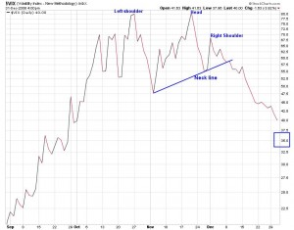](http://www.stocktradingtogo.com/wp-content/uploads/2009/05/vix-head-and-shoulders.jpg?a7518c)Click to Enlarge](http://www.stocktradingtogo.com/wp-content/uploads/2009/05/vix-head-and-shoulders.jpg?a7518c)

### **Second**

The [head-and-shoulders pattern](http://www.investopedia.com/terms/h/head-shoulders.asp) is one of the most popular and reliable chart patterns in technical analysis. And as one might imagine from the name, the pattern looks like a head with two shoulders.   
  
Head and shoulders is a [reversal pattern](http://www.investopedia.com/terms/r/reversal.asp) that, when formed, signals the security is likely to move against the previous trend. There are two versions of the head-and-shoulders pattern. The head-and-shoulders top is a signal that a security's price is set to fall, once the pattern is complete, and is usually formed at the [peak](http://www.investopedia.com/terms/p/peak.asp) of an [upward trend](http://www.investopedia.com/terms/u/uptrend.asp). The second version, the head-and-shoulders bottom (also known as inverse head and shoulders), signals that a security's price is set to rise and usually forms during a [downward trend](http://www.investopedia.com/terms/d/downtrend.asp).   
  
Both of these head and shoulders have a similar construction in that there are four main parts to the head-and-shoulder chart pattern: two shoulders, a head and a [neckline](http://www.investopedia.com/terms/n/neckline.asp). The patterns are confirmed when the neckline is broken, after the formation of the second shoulder.

|  |
| --- |
| http://i.investopedia.com/inv/articles/site/HeadandShoulder.gif |
| Figure 1: Head-and-shoulders pattern |

The head and shoulders are sets of peaks and [troughs](http://www.investopedia.com/terms/t/trough.asp). The neckline is a level of [support](http://www.investopedia.com/terms/s/support.asp) or[resistance](http://www.investopedia.com/terms/r/resistance.asp). The head and shoulders pattern is based on Dow Theory's peak-and-trough analysis. An upward trend, for example, is seen as a period of successive rising peaks and rising troughs. A downward trend, on the other hand, is a period of falling peaks and troughs. The head-and-shoulders pattern illustrates a weakening in a trend where there is deterioration in the peaks and troughs.   
  
**Head and Shoulders Top**Again, the head-and-shoulders top signals to chart users that a security's price is likely to make a downward move, especially after it breaks below the neckline of the pattern. Due to this pattern forming mostly at the peaks of upward trends, it is considered to be a trend-reversal pattern, as the security heads down after the pattern's completion.   
  
This pattern has four main steps for it to complete itself and signal the reversal. The first step is the formation of the left shoulder, which is formed when the security reaches a new high and retraces to a new low. The second step is the formation of the head, which occurs when the security reaches a higher high, then retraces back near the low formed in the left shoulder. The third step is the formation of the right shoulder, which is formed with a high that is lower than the high formed in the head but is again followed by a retracement back to the low of the left shoulder. The pattern is complete once the price falls below the neckline, which is a support line formed at the level of the lows reached at each of the three retracements mentioned above.   
  
**Inverse Head and Shoulders (Head-and-Shoulders Bottom)**The [inverse head-and-shoulders pattern](http://www.investopedia.com/terms/i/inverseheadandshoulders.asp) is the exact opposite of the head-and-shoulders top, as it signals that the security is set to make an upward move. Often coming at the end of a [downtrend](http://www.investopedia.com/terms/d/downtrend.asp), the inverse head and shoulders is considered to be a reversal pattern, as the security typically heads higher after the completion of the pattern.

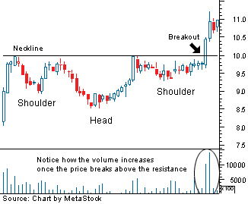Figure 2: Inverse head-and-shoulders pattern

Again, there are four steps to this pattern, starting with the formation of the left shoulder, which occurs when the price falls to a new low and rallies to a high. The formation of the head, which is the second step, occurs when the price moves to a low that is below the previous low, followed by a return to the previous high. This move back to the previous high creates the neckline for this chart pattern. The third step is the formation of the right shoulder, which sees a sell-off, but to a low that is higher than the previous one, followed by a return to the neckline. The pattern is complete when the price breaks above the neckline.

**The Breaking of the Neckline and the Potential Return Move**As seen from the above, the head-and-shoulders pattern is complete when the neckline is broken; the trend is then considered reversed, and the security should be heading in a new direction. The point of breakout is when most traders following the pattern would enter the security.   
  
However, the security will not always just continue in the direction suggested by the pattern after the breakout. For this reason it's important to be aware of what is known as a "throwback" move. This situation occurs when the price breaks through the neckline, setting a new high or low (depending on the pattern), followed by a retreat back to the neckline.

|  |
| --- |
| http://i.investopedia.com/inv/articles/site/Throwback.gif |
| Figure 3: Throwback move illustration |

This move back to the neckline is considered to be a test of the pattern and the newly reversed support or resistance. Remember that when a trend shifts (or a reversal pattern is confirmed), what was once support now become resistance, and vice versa. In the case of an inverse head-and-shoulders pattern (as shown in the chart above), the neckline represented a level of resistance for the security before it broke out. Upon the security moving above the neckline to confirm the pattern, the restrictive neckline becomes support for any move back up.   
  
While it can be alarming to see a security move in the opposite direction of the trend suggested by the pattern, it isn't all that bad. The reason being that the successful test of this new level of support or resistance helps to strengthen the pattern and its suggested new direction. So, it's important to wait for the pattern to test out and not sell out too quickly - before the pattern makes its bigger moves.   
  
**Volume**In technical analysis and chart-pattern analysis, [volume](http://www.investopedia.com/terms/v/volume.asp) plays an important role as it is used as a secondary indicator. Volume indicates activity and money movement. When volume is high, there is a lot of activity and money changing hands - making it an important [indicator](http://www.investopedia.com/terms/i/indicator.asp)to follow.   
  
For the head-and-shoulders pattern, volume is used mainly at the point of breakout to help confirm the pattern. At this point, it's important that the breakout happens on a large-volume move. For a head-and-shoulders top, when the price breaks below the neckline (in a downward direction), it's best when this occurs during a large volume increase, which signals heavy selling. This strongly indicates that the underlying supply and demand in the market is moving in the same direction the chart pattern is predicting.   
  
Volume can also be used as a secondary indicator during the formation of the pattern, well before the breakout, to gain an idea of the pattern's strength.   
  
For a head-and-shoulders top, the left shoulder should show heavy volume as it hits its new peak. Low volume should take the left shoulder down to the neckline. The run towards the peak in the head should be on lighter volume compared to the peak formed in the left shoulder.   
  
This should be a warning, as volume should move with trends - not against them. The peak formed in the right shoulder should be seen with even lighter volume than in either the head or the left shoulder. And again, the volume should be high when the neckline is broken, which is by far the most important area to watch in terms of volume. If the volume is lighter on the neckline break, the chances of the price moving back to the neckline after breaking is greater than if the neckline break was accompanied by large volume.   
  
This interaction of volume and price movement in forming the reversal signal is not set in stone. However, it is the general tendency in the chart pattern.   
 **Slope of the Neckline**Another key factor in the head-and-shoulders pattern is the formation of the neckline. The reason being that the neckline acts as support or resistance during the formation of the pattern, along with being the entry point at which the pattern confirms itself.   
  
In most of the above examples, the neckline is flat, but this need not be the case for the pattern to provide a potential trade. In most cases, the neckline will in fact be slanted either up or down. In general, a technically strong head-and-shoulders top should have a flat or slightly upward-trending neckline. For a head-and-shoulders bottom, it should be flat or slightly downward, similar to the one shown above in figure 3.   
  
**Price Objective**An important, but often overlooked, factor in technical analysis and chart patterns is the calculation of price objectives. This is a measure of where the price is considered to be headed, based on a confirmed pattern.   
  
While the price's direction is already known, based on the signal, what needs to be calculated is the projected price movement. This is done so that targets can be set, protective stops can be instituted and the worth of a trade can be evaluated.

|  |
| --- |
| http://i.investopedia.com/inv/articles/site/CAReport_HeadShoulder.gif |
| Figure 4 |

This is measured based on the height of the chart pattern, which is essentially the distance in price between the peak of the head and the neckline. For example, let's say that in a head-and-shoulders top, the peak of the head is formed at $50 and the neckline was established at $40 - a difference of $10.   
  
The price objective is calculated by subtracting the price at which the pattern breaks the neckline ($40) by the difference between the head and the neckline ($10). Based on this example, the price objective is $30 ($40-$10).   
  
This price objective is not an absolute and is used as a guideline to the attractiveness of a trade. The larger the difference between the objective and the price at the neckline, the more worth the trade has, as it will yield greater returns.

## **Triple bottom/top**

### First

This is a variation of a head and shoulders pattern. The main difference is that whereas the head and shoulders offers three points at different prices, the triple top/bottom offers them at the same price. Cliff Natural Resources (CLF) shows three highs at the same level (blue circles). This indicates a potential triple top that would drive prices toward $20.

[Click to Enlarge  
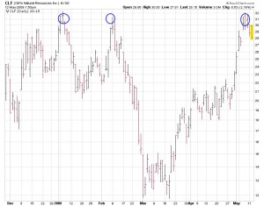](http://www.stocktradingtogo.com/wp-content/uploads/2009/05/clf-tripple-top.jpg?a7518c)

### **Second**

**Triple Top**This bearish reversal pattern is formed when a security that is trending upward tests a similar level of resistance three times without breaking through. Each time the security tests the resistance level, it falls to a similar area of support. After the third fall to the support level, the pattern is complete when the security falls through the support; the price is then expected to move in a downward trend.

|  |
| --- |
| http://i.investopedia.com/inv/articles/site/tripletopnew.gif |
| Figure 1: Triple top reversal |

The first step in this pattern is the creation of a new high in an uptrend that is stalled by selling pressure, which forms a level of resistance. The selling pressure causes the price to fall until it finds a level of support, as buyers move back into the security. The buying pressure sends the price back up to the area of resistance the security previously met. Again, the sellers enter the market and send the security back down to the support level.

This up-and-down movement is repeated for the third time; but this time the buyers, after failing three times, give up on the security, and the sellers take over. Upon falling through the level of support, the security is expected to trend downward.   
  
This pattern can be difficult to spot in the early stages as it will initially look like a [double-top pattern](http://www.investopedia.com/terms/d/doubletop.asp), which was discussed in a previous section. The most important thing here is that one waits for the price to move past the level of resistance before entering the security, as the security could actually just end up being range-bound, where it trades between the two levels for some time.   
  
In the triple-top formation, each test of resistance at the upper end should be marked with declining volume at each successive peak. And again, when the price breaks below the support level, it should be accompanied by high volume.   
  
Once the signal is formed, the price objective is based on the size of the chart pattern or the price distance between the level of resistance and support. This is then deducted from the [breakout point](http://www.investopedia.com/terms/b/breakout.asp).   
  
**Triple Bottom**This bullish reversal pattern has all of the same attributes as the triple top but signals a reversal of a [downward trend](http://www.investopedia.com/terms/d/downtrend.asp). The triple-bottom pattern illustrates a security that is trading in a downtrend and attempts to fall through a level of support three times, each time moving back to a level of resistance. After the third attempt to push the price lower, the pattern is complete when the price moves above the resistance level and begins trading in an upward trend.

|  |
| --- |
| http://i.investopedia.com/inv/articles/site/triplebottomnew.gif |
| Figure 2: Triple bottom reversal |

This pattern begins by setting a new low in a downtrend, which is followed by a rally to a high. This sets up the range of trading for the triple-bottom pattern. After hitting the high, the price again comes under selling pressure, which sends it back down to the previous low. Buyers again move back into the security at this support level, sending the price back up again, usually to the previous high.   
  
This is repeated a third time, but after failing again to move to a new low, the pattern is complete when the security moves above the resistance level to begin trading in an uptrend.   
  
In this pattern, volume plays a role similar to the triple top, declining at each trough as it tests the support level, which is a sign of diminishing selling pressure. Again, volume should be high on a breakout above the resistance level on the completion of the pattern.   
  
The price objective will also initially be calculated as the distance of the chart pattern added to the price breakout. So if the chart pattern is formed between $50 and $30 at a price breakout of $50 the price objective is $70 ($50+$20).   
  
**Meaning Behind Triple Tops and Bottoms**The significance of these two formations is that an established trend has hit a major section of support/resistance, which stops the trend's ability to continue. This is an indication that the buying or selling pressure that is supporting the trend is beginning to weaken. It also is an indication that the opposite pressure is gaining strength.   
  
The chart pattern is signaling that there is a shift in the supply and demand of the security and of the balance between buyers and sellers. When a reversal signal is formed in a triple top, there is a shift from buyers moving the security upward to sellers moving the security downward.

## **Double bottom/top**

### First

This is more frequent as it requires only two data points whereas the triple top and head and shoulders require three points. When we see two prices at the same level, it indicates stocks have reached either a top or bottom. As with most technical patterns, reversals on heavy volume reinforce the movement. Returning to KO, the black circle indicates a spike in volume that accompanied the reversal. This should have warned all those owning the shares that the massive reversal was occurring.

[[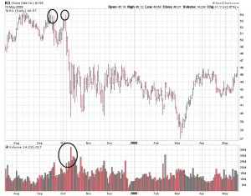](http://www.stocktradingtogo.com/wp-content/uploads/2009/05/ko-double-top.jpg?a7518c)Click to Enlarge](http://www.stocktradingtogo.com/wp-content/uploads/2009/05/ko-double-top.jpg?a7518c)

### Second

The [double top](http://www.investopedia.com/terms/d/doubletop.asp) and [double bottom](http://www.investopedia.com/terms/d/doublebottom.asp) are another pair of well-known chart patterns whose names don't leave much to the imagination. These two reversal patterns illustrate a security's attempt to continue an existing trend. Upon several attempts to move higher, the trend is reversed and a new trend begins. These chart patterns formed will often resemble what looks like a "W" (for a double bottom) or an "M" (double top).   
  
**Double Top**The double-top pattern is found at the [peaks](http://www.investopedia.com/terms/p/peak.asp) of an upward trend and is a clear signal that the preceding upward trend is weakening and that buyers are losing interest. Upon completion of this pattern, the trend is considered to be reversed and the security is expected to move lower.   
  
The first stage of this pattern is the creation of a new high during the upward trend, which, after peaking, faces [resistance](http://www.investopedia.com/terms/r/resistance.asp) and sells off to a level of [support](http://www.investopedia.com/terms/s/support.asp). The next stage of this pattern will see the price start to move back towards the level of resistance found in the previous run-up, which again sells off back to the support level. The pattern is completed when the security falls below (or [breaks down](http://www.investopedia.com/terms/b/breakdown.asp)) the support level that had backstopped each move the security made, thus marking the beginnings of a downward trend.

|  |
| --- |
| http://i.investopedia.com/inv/articles/site/Doubletop.gif |
| Figure 1: Double-top pattern |

It's important to note that the price does not need to touch the level of resistance but should be close to the prior peak. Also, when using this chart pattern one should wait for the price to break below the key level of support before entering. Trading before the signal is formed can yield disastrous results, as the pattern is only setting up the possibility for the trend reversal and could trade within this banded range for some time without falling through.   
  
This pattern is a clear illustration of a battle between buyers and sellers. The buyers are attempting to push the security but are facing resistance, which prevents the continuation of the upward trend. After this goes on a couple of times, the buyers in the market start to give up or dry up, and the sellers start to take a stranglehold of the security, sending it down into a new downtrend.

Again, [volume](http://www.investopedia.com/terms/v/volume.asp) should be an important focus as one should look for an increase in volume when the security falls below the support level. Also, as in other chart patterns, do not be alarmed if there is a return to the previous support level that has now become a resistance level in the newly established trend.   
  
**Double Bottom**This is the opposite chart pattern of the double top as it signals a reversal of the downtrend into an [uptrend](http://www.investopedia.com/terms/u/uptrend.asp). This pattern will closely resemble the shape of a "W".

|  |
| --- |
| http://i.investopedia.com/inv/articles/site/Doublebottom.gif |
| Figure 2: Double-bottom pattern |

The double bottom is formed when a downtrend sets a new low in the price movement. This downward move will find support, which prevents the security from moving lower. Upon finding support, the security will rally to a new high, which forms the security's resistance point. The next stage of this pattern is another sell-off that takes the security down to the previous low. These two support tests form the two bottoms in the chart pattern. But again, the security finds support and heads back up. The pattern is confirmed when the price moves above the resistance the security faced on the prior move up.   
  
Remember that the security needs to [break](http://www.investopedia.com/terms/b/breakout.asp) through the support line to signal a reversal in the downward trend and should be done on higher volume. As in the double top, do not be surprised if the price returns to the breakout point to test the new support level in the upward trend.   
 **Price Objective and Adjustments**It's important to get an idea as to the size of the resulting move once the signal has been formed. In both the double top and double bottom, the initial price objective can be measured by taking the price distance between the support and resistance levels or the range that chart pattern trades.   
  
For example, assume in a double top that the upward trend peaks at $50 and retraces to $40 to form the support level. Assuming everything follows through on the chart pattern and the support level is broken at $40, the initial price objective should be set at $30 ($40-$10).   
  
Often in [technical analysis](http://www.investopedia.com/terms/t/technicalanalysis.asp) and chart patterns, we're presented with an ideal chart setup; but in reality the pattern doesn't always look as perfect as it's supposed to. In double tops and double bottoms one thing to remember is that the price on the second test does not always need to reach the same distance as the first test.   
  
Another problem that can occur is the second testing point, where the top or bottom actually breaks the level that the first top or bottom test created. If this occurs, it can give a signal that the previous trend will continue - instead of reverse - as the pattern suggests. However, don't be too quick to abandon the pattern as it could still materialize.   
  
If the price does, in fact, move above the prior test, look to see if the move was accompanied by large volume, suggesting a trend continuation. For example, if on the second test of a double bottom the price falls below the support line on heavy volume, it is a good sign the downward trend will continue and not reverse. If the volume is very weak, it could just be a last attempt to continue the downward trend, but the trend will ultimately reverse.   
  
The double tops and double bottoms are strong reversal patterns that can provide trading opportunities. But it is important to be careful with these patterns as the price can often move either way. Consequently, it's important that the trade is implemented once the support/resistance line is broken.

## **Saucers**

Saucers show a gradual turn from downtrend to sideways to uptrend. They are long-lasting base-building patterns that indicate trends are changing. Copper offers an example whereby a long downtrend eventually bottomed, moved sideways, and then pushed higher. This lets us know that the recent lows near $130 should serve as a long-term base years into the future.

[[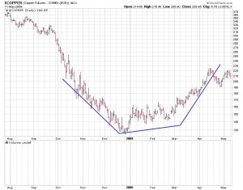](http://www.stocktradingtogo.com/wp-content/uploads/2009/05/copper-saucer.jpg?a7518c)Click to Enlarge](http://www.stocktradingtogo.com/wp-content/uploads/2009/05/copper-saucer.jpg?a7518c)

While one list cannot capture every possible chart pattern, these five will allow you to devel

## Symmetrical Triangle – Symmetrical Triangle Pattern

Extra : <http://www.chartpatterns.com/symmetricaltriangles.htm>

### First

Symmetrical triangles are usually continuation patterns with converging trend lines.  The technical buy point from a symmetrical triangle is the upside break, while a downside break is a technical sell signal.  Ideally, a stock breaks out from a symmetrical triangle prior to reaching the apex of the triangle with volume expansion.

Context:  Found within a trend, the symmetrical triangle forms as a consolidation period within the trend.

Appearance:  The trend is well-established, and the formation of the symmetrical triangle is a resting phase for the stock.  [**Trend lines**](http://thestockbandit.com/trend-lines/) can be drawn connecting the reaction lows and highs of the resting phase, which should reveal converging price action with symmetry.  Volume contracts during the consolidation.  A breakout should occur somewhere between 50-75% into the triangle pattern.  An early or late breakout is more prone to failure, and therefore a less reliable breakout.  Price may find the apex to be [**support or resistance**](http://thestockbandit.com/support-resistance/) following a breakout, so a successful test of the triangle adds reliability to this pattern.

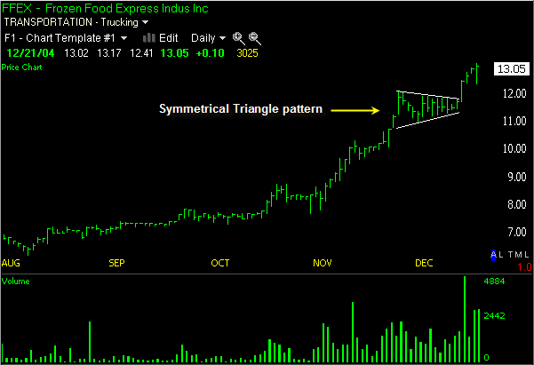

### Second

The symmetrical triangle is mainly considered to be a [continuation](http://www.investopedia.com/terms/c/continuationpattern.asp) pattern that signals a period of consolidation in a trend followed by a resumption of the prior trend. It is formed by the convergence of a descending [resistance](http://www.investopedia.com/terms/r/resistance.asp) line and an ascending [support](http://www.investopedia.com/terms/s/support.asp) line. The two trendlines in the formation of this triangle should have a similar slope converging at a point known as the apex. The price of the security will bounce between these trendlines, towards the apex, and typically breakout in the direction of the prior trend.   
  
If preceded by a downward trend, the focus should be on a break below the ascending support line. If preceded by an upward trend, look for a break above the descending resistance line. However, this pattern doesn't always lead to a continuation of the previous trend. A break in the opposite direction of the prior trend should signal the formation of a new trend. 

|  |
| --- |
| http://i.investopedia.com/inv/articles/site/Symmetrical.gif |
| Figure 1: Symmetrical triangle |

Above is an example of a symmetrical triangle that is preceded by an upward trend. The first part of this pattern is the creation of a high in the upward trend, which is followed by a sell-off to a low. The price then moves to another high that is lower than the first high and again sells off to a low, which is higher than the previous low. At this point the trendlines can be drawn, which creates the apex. The price will continue to move between these lines until breakout.   
  
The pattern is complete when the price breaks out of the triangle - look for an increase in volume in the direction of the breakout. This pattern is also susceptible to a return to the previous support or resistance line that it just broke through, so make sure to watch for this level to hold if it does indeed break out.

## Ascending Triangle – Ascending Triangle Pattern

Extra : <http://www.chartpatterns.com/ascendingtriangles.htm>

### First

Ascending triangle patterns are bullish and often form within [**uptrends in stocks**](http://thestockbandit.com/uptrend-stock/) as continuation patterns.  The ascending triangle pattern resembles a narrowing triangle with a horizontal line of overhead resistance for the stock and an ascending trend line or rising trend line beneath the stock.  The overhead [**resistance**](http://thestockbandit.com/support-resistance/) temporarily prevents the stock from advancing higher, while the rising trend line beneath the stock signals that buyers are still present.  An upside penetration of the upper horizontal trend line is a technical buy signal for a stock breaking out from an ascending triangle pattern.

Context:  Found within an uptrend, the ascending triangle forms as a consolidation period within the uptrend and indicates upside continuation will follow.

Appearance:  The trend is well-established, and the formation of the ascending triangle is a resting phase for the stock.  A trend line can be drawn connecting multiple highs during this time, which should be horizontal to indicate some resistance above current prices.  A second trend line is an ascending or rising trend line which connects multiple higher lows during this period, completing the ascending triangle pattern.  A breakout should occur about 2/3 of the way into the triangle, and happens when the overhead resistance is penetrated to the upside and buyers rush in to accumulate shares.  A stock which does not break out prior to reaching the apex of the triangle is generally sluggish and often a less reliable trading candidate.  [**Volume**](http://thestockbandit.com/volume/) contracts during the consolidation phase, and should expand during the breakout.

Breakout Expectation:  The widest portion of the triangle may be measured and added to the breakout point (resistance level) to determine the expected price advance which follows.

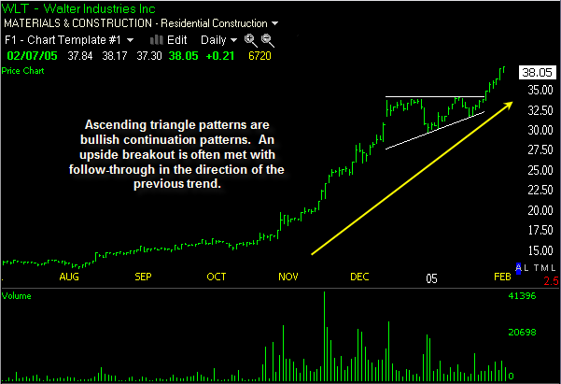

### Second

The ascending triangle is a bullish pattern, which gives an indication that the price of the security is headed higher upon completion. The pattern is formed by two trendlines: a flat trendline being a point of resistance and an ascending trendline acting as a price support.   
  
The price of the security moves between these trendlines until it eventually breaks out to the upside. This pattern will typically be preceded by an upward trend, which makes it a continuation pattern; however, it can be found during a downtrend. 

|  |
| --- |
| http://i.investopedia.com/inv/articles/site/AscendingTriangle.gif |
| Figure 2: Ascending triangle |

As seen above, the price moves to a high that faces resistance leading to a sell-off to a low. This follows another move higher, which tests the previous level of resistance. Upon failing to move past this level of resistance, the security again sells off - but to a higher low. This continues until the price moves above the level of resistance or the pattern fails.   
  
The most telling part of this pattern is the ascending support line, which gives an indication that sellers are starting to leave the security. After the sellers are knocked out of the market, the buyers can take the price past the resistance level and resume the upward trend.   
  
The pattern is complete upon breakout above the resistance level, but it can fall below the support line (thus breaking the pattern), so be careful when entering prior to [breakout](http://www.investopedia.com/terms/b/breakout.asp).

## Descending Triangle – Descending Triangle Pattern

Extra : <http://www.chartpatterns.com/descendingtriangles.htm>

### First

Descending triangle patterns are bearish and often form within downtrends in stocks as continuation patterns.  The descending triangle pattern resembles a narrowing triangle with a horizontal line of support beneath the stock and a descending trend line or [**downtrend line**](http://thestockbandit.com/downtrend-stock/) above the stock.  The [**horizontal trend line**](http://thestockbandit.com/support-resistance/) serves as support which temporarily prevents the stock from declining, while the descending trend line above the stock signals that sellers are still present.  A downside penetration of the horizontal trend line is a technical sell signal for a stock breaking down from a descending triangle pattern, and indicates distribution will follow.

Context:  Found within a downtrend, the descending triangle forms as a [**consolidation**](http://thestockbandit.com/consolidation/) period within the downtrend and indicates downside continuation will follow.

Appearance:  The trend is well-established, and the formation of the descending triangle is a resting phase for the stock.  A trend line can be drawn connecting multiple lows during this time, which should be horizontal to indicate some support beneath current prices.  A second trend line is a descending or downtrend line which connects multiple lower highs during this period, completing the descending triangle pattern.  A breakdown should occur about 2/3 of the way into the triangle, and happens when the support level is broken and sellers rush to unload shares.  A stock which does not break down prior to reaching the apex of the triangle is generally sluggish and often a less reliable trading candidate.  Volume contracts during the consolidation phase, and should expand during the breakdown.

Breakdown Expectation:  The widest portion of the triangle may be measured and subtracted from the breakdown point (support level) to determine the expected price decline which follows.

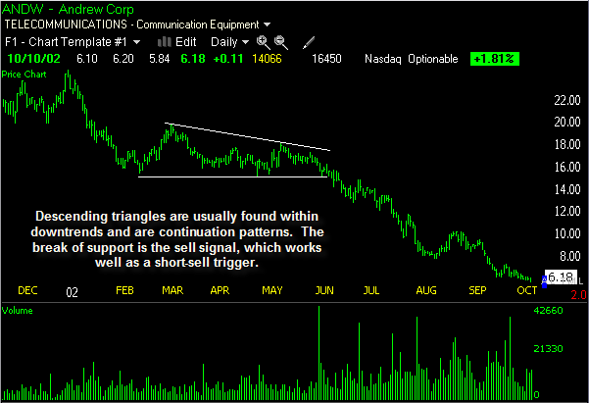

### Second

The descending triangle is the opposite of the ascending triangle in that it gives a bearish signal to chartists, suggesting that the price will trend downward upon completion of the pattern. The descending triangle is constructed with a flat support line and a downward-sloping resistance line.   
  
Similar to the ascending triangle, this pattern is generally considered to be a continuation pattern, as it is preceded by a downward trendline. But again, it can be found in an uptrend.

|  |
| --- |
| http://i.investopedia.com/inv/articles/site/DescendingTriangle.gif |
| Figure 3: Descending triangle |

The first part of this pattern is the fall to a low that then finds a level of support, which sends the price to a high. The next move is a second test of the previous support level, which again sends the stock higher - but this time to a lower level than the previous move higher. This is repeated until the price is unable to hold the support level and falls below, resuming the downtrend.   
  
This pattern indicates that buyers are trying to take the security higher, but continue to face resistance. After several attempts to push the stock higher, the buyers fade and the sellers overpower them, which sends the price lower.

## Cup and Handle Pattern

### First

The cup and handle pattern is a well-known chart pattern, which is a continuation setup for higher prices.

Cup and handle patterns are found within uptrends, and are named for their appearance which resembles a cup and handle.  This pattern is the result of a resting period in the stock, with the round cup shape followed by narrow price action which forms the appearance of the handle.  The technical buy point is as the stock clears the handle area to the upside, ideally on volume expansion.

Context:  Found within an uptrend.

Appearance:  The cup is rounded, not sharp, and the handle portion is similar to a flag or pennant with slight retracement to the downside or horizontal movement (but no upward movement).  The cup at the deepest point will generally have retraced about 30% of the prior price advance.

Breakout Expectation:  The height of the cup is the expected gain that a breakout should achieve, added to the breakout point at the top of the handle.

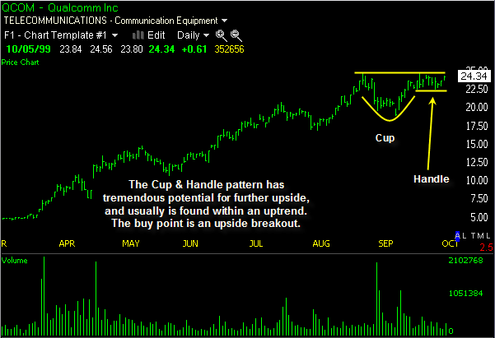

### Second

A [cup-and-handle pattern](http://www.investopedia.com/terms/c/cupandhandle.asp) resembles the shape of a tea cup on a chart. This is a bullish[continuation pattern](http://www.investopedia.com/terms/c/continuationpattern.asp) where the upward trend has paused, and traded down, but will continue in an upward direction upon the completion of the pattern. This pattern can range from several months to a year, but its general form remains the same.   
  
The cup-and-handle pattern is preceded by an upward move, which stalls and sells off. The sell-off is what forms the initial part of this pattern. After the sell-off, the security will basically trade flat for an extended period of time, with no clear trend. The next part of the pattern is the upward move back towards the peak of the preceding upward move. The last part of the pattern, known as the handle, is a relatively smaller downward move before the security moves higher and continues the previous trend.   
  
**Components of the Cup and Handle**There are several components of the cup and handle that should be noted in order to evaluate the potential trading signal. First, it's important that there is an upward trend before the formation of the cup and handle. In general, the larger the prior trend is, the lower the potential for a large [breakout](http://www.investopedia.com/terms/b/breakout.asp) after the pattern has been completed. The reason being that a lot of the run-up in the security happened prior to the formation of the cup, again weakening the size of the potential upward move.

|  |
| --- |
| http://i.investopedia.com/inv/articles/site/Cup_and_Handle.gif |
| Figure 1: Cup-and-handle pattern |

The construct of the cup itself is also important: it should be a nicely rounded formation, similar to a semi-circle. The reason is that a cup-and-handle pattern is a signal of consolidation within a trend, where the weaker investors leave the market and new buyers and resolute holders stay in the security. If the shape of the cup is too sharp (or quick), it is not considered a true consolidation phase in the upward trend and thus weakens the potential trade signal.   
  
The cup's height should also be a focus: a traditional cup-and-handle pattern should be between one-third and two-thirds the size of the previous upward movement, depending on market volatility. So, if the move of the preceding trend was from $10 to $35, the height of the cup should be at least $8 (roughly $25 x 33%) to $16 (roughly $25 x 66%). The height of the cup can also be used as an initial price target after the pattern completes itself and breaks out of the handle.   
  
***The Handle***   
Another important component to watch is the handle, as it completes the pattern. As mentioned before, the handle is the downward move by the security after the upward move on the right side of the cup. If the handle is downward moving, the general rule is that the handle's downward movement can retrace one-third of the gain made in the right side of the cup. During this downward move, a descending trendline can be drawn, which forms the signal for the breakout. A move by the security above this descending trendline is a signal that the prior upward trend is set to begin.   
  
A more conservative breakout signal would be above the price point of the two peaks in the cup. This is the price where the initial upward trend peaked and the point where the cup's upward move on the right side peaked before entering the handle. A breakout above this point is the strongest signal of a true resumption of the prior trend.   
  
As with most chart patterns, volume is vital in the confirmation of the pattern itself and the signal formed. Again, the most important area of focus is the breakout: the stronger the volume on the upward breakout, the clearer the sign that the upward trend will continue. Like the head-and-shoulders pattern, the price may move back to the trendline to test the support.   
  
The cup and handle is another time-tested pattern that has created valuable gains for investors. The components mentioned above are not absolutes but help to highlight areas of focus as a security trades in a cup and handle.

## Bull Flag – Bull Flag Pattern

The [flag](http://www.investopedia.com/terms/f/flag.asp) and [pennant](http://www.investopedia.com/terms/p/pennant.asp) patterns are two [continuation](http://www.investopedia.com/terms/c/continuationpattern.asp) patterns that closely resemble each other, differing only in their shape during the pattern's consolidation period. This is the reason the terms flag and pennant are often used interchangeably. A flag is a rectangular shape, while the pennant looks more like a [triangle](http://www.investopedia.com/terms/t/triangle.asp).   
  
These two patterns are formed when there is a sharp price movement followed by generally sideways price movement, which is the flag or pennant. The pattern is complete when there is a price breakout in the same direction of the initial sharp price movement. The following move will see a similarly sharp move in the same direction as the prior sharp move. The complete move of the chart pattern - from the first sharp move to the last sharp move - is referred to as the flag pole.   
  
The flag or pennant is considered to be flying at half-mast, as the distance of the initial price movement is thought to be roughly equal to the proceeding price move. The reason these patterns form is that after a large price movement, the market consolidates, or pauses, before resuming the initial trend

### First

The bull flag pattern is found within an [**uptrend**](http://thestockbandit.com/uptrend-stock/) in a stock.  This pattern is named for the resemblance of a flag on a pole.  The bull flag is a continuation pattern which only slightly retraces the advance preceding it.  The technical buy point is when price penetrates the upper trend line of the flag area, ideally on volume expansion.

Context:  Found within an uptrend.

Appearance:  The advance has solid volume and the upward price action is strong, which forms the vertical look of a flagpole.  The resting period and slight retracement is narrow price action with a slight downward tilt or is horizontal (but no upward movement) with volume contracting during the flag portion of the pattern.  The flag portion of the pattern has highs and lows which can be connected by small trend lines which are parallel, giving the flag portion the look of a small channel.

Breakout Expectation:  The height of the flagpole may be added to the breakout area at the end of the flag to determine the expected advance.  This is why the bull flag pattern is often found in the middle of stock advances.

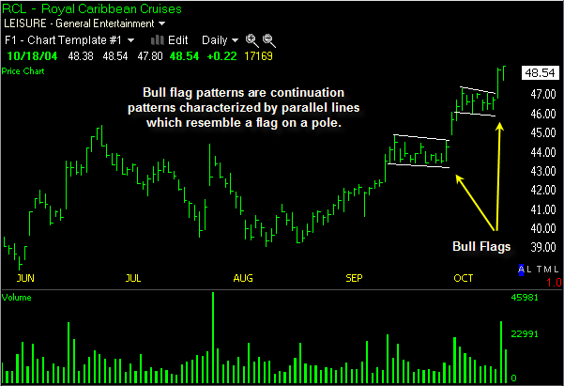

### Second

The flag pattern forms what looks like a rectangle. The rectangle is formed by two parallel trendlines that act as support and resistance for the price until the price breaks out. In general, the flag will not be perfectly flat but will have its trendlines sloping. 

|  |
| --- |
| http://i.investopedia.com/inv/articles/site/flag.gif |
| Figure 1: The flag pattern |

In general, the slope of the flag should move in the opposite direction of the initial sharp price movement; so if the initial movement were up, the flag should be downward sloping.   
  
The buy or sell signal is formed once the price breaks through the support or resistance level, with the trend continuing in the prior direction. This breakthrough should be on heavier volume to improve the signal of the chart pattern. 

## Bear Flag – Bear Flag Pattern

The bear flag pattern is found in a downtrending stock.  This pattern is named for the resemblance of an inverted flag on a pole.  The bear flag is a continuation pattern which only slightly retraces the decline preceding it.  The technical sell point is when price penetrates the lower trend line of the flag area, ideally on volume expansion.

Context:  Found within a [**downtrend**](http://thestockbandit.com/downtrend-stock/).

Appearance:  The decline has solid volume and consistent downward price action, which forms the vertical look of an inverted flagpole.  The resting period and slight retracement is narrow price action with a slight upward tilt or is horizontal (but no downward movement) with volume contracting during the flag portion of the pattern.  The flag portion of the pattern has highs and lows which can be connected by small trend lines which are parallel, giving the flag portion the look of a small channel.

Breakout Expectation:  The height of the flagpole may be subtracted from the breakout area at the end of the flag to determine the expected decline which follows.  This is why the bear flag pattern is often found in the middle of stock declines.

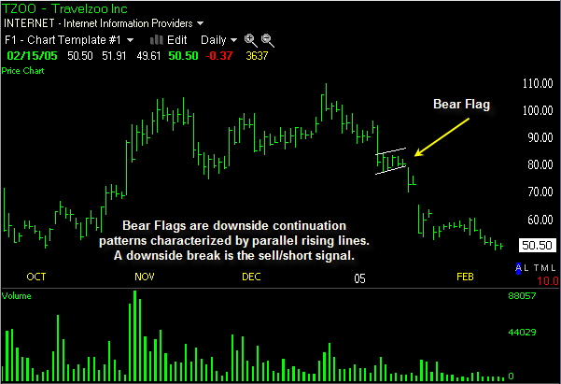

## Bull Pennant – Bull Pennant Pattern

### First

The bull pennant pattern is found within an [**uptrend**](http://thestockbandit.com/uptrend-stock/) in a stock.  This pattern is named for the resemblance of a pennant on a pole.  The bull pennant is a continuation pattern with narrowing price action following a strong advance.  The technical buy point is when price penetrates the upper [**trend line**](http://thestockbandit.com/trend-lines/) of the pennant area, ideally on volume expansion.

Context:  Found within an uptrend.

Appearance:  The advance has solid volume and the upward price action is strong, which forms the vertical look of a flagpole.  The resting period and narrowing price action is characterized by volume contraction as upside intensity is temporarily interrupted.  This forms a pennant which also resembles a small [**symmetrical triangle**](http://thestockbandit.com/symmetrical-triangle/).  The pennant portion of the pattern has highs and lows which can be connected by small trend lines which converge.

Breakout Expectation:  The height of the flagpole may be added to the breakout area at the end of the pennant to determine the expected advance which follows.  This is why the bull pennant pattern is often found in the middle of stock advances as a continuation pattern.

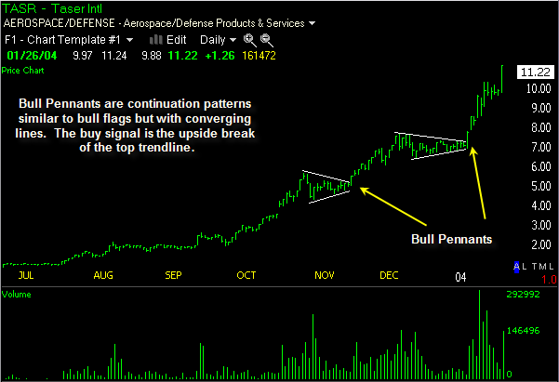

### Second

The pennant forms what looks like a [symmetrical triangle](http://www.investopedia.com/terms/s/symmetricaltriangle.asp), where the support and resistance trendlines converge towards each other. The pennant pattern does not need to follow the same rules found in triangles, where they should test each support or resistance line several times. Also, the direction of the pennant is not as important as it is in the flag; however, the pennant is generally flat. 

|  |
| --- |
| http://i.investopedia.com/inv/articles/site/Pennant.gif |
| Figure 2: The Pennant |

**General Ideas**While the construct of the pause in the trend is different for the flag and pennant, the attributes of the chart patterns themselves are similar. It is vital that the price movement prior to the flag or pennant be a strong, sharp move.   
  
Typically, these patterns take less time to form during downtrends than in uptrends. In terms of pattern length, they are generally short-term patterns lasting one to three weeks, but can be formed over longer periods.   
  
The volume, as with most breakout signals, should be seen as strong during the breakout to confirm the signal. Upon breakout, the initial price objective is equal to the distance of the prior move added to the breakout point. For example, if a prior sharp up movement was from $30 to $40, then the resulting price objective from a price breakout of $38 would be $48 ($38+$10).

## Bear Pennant – Bear Pennant Pattern

http://0.gravatar.com/avatar/0e35ab35a1e1cd642ca17036956dcc87?s=30&d=http%3A%2F%2F0.gravatar.com%2Favatar%2Fad516503a11cd5ca435acc9bb6523536%3Fs%3D30&r=G

The bear pennant pattern is found within a **[downtrending stock](http://thestockbandit.com/downtrend-stock/" \o "Downtrending Stock)**.  This pattern is named for the resemblance of an inverted pennant on a pole.  The bear pennant is a continuation pattern with narrowing price action following a constant decline.  The technical sell point is when price penetrates the lower trend line of the pennant area, ideally on volume expansion.

Context:  Found within a downtrend.

Appearance:  The decline has solid volume and the downward price action is consistent, which forms the look of an inverted flagpole.  The resting period and narrowing price action is characterized by volume contraction as downside intensity is temporarily interrupted.  This forms a pennant which also resembles a small [**symmetrical triangle**](http://thestockbandit.com/symmetrical-triangle/).  The pennant portion of the pattern has highs and lows which can be connected by small trend lines which converge.

Breakout Expectation:  The height of the flagpole may be subtracted from the breakout area at the end of the pennant to determine the expected decline which follows.  This is why the bear pennant pattern is often found in the middle of stock declines as a continuation pattern.

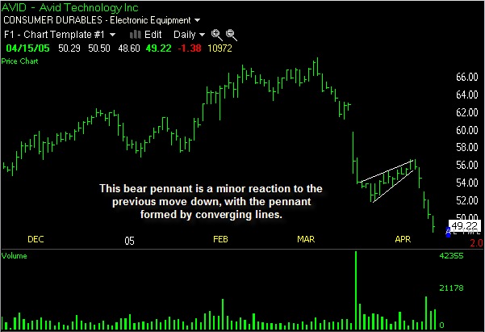

## Descending Channel – Descending Channel Pattern

http://0.gravatar.com/avatar/0e35ab35a1e1cd642ca17036956dcc87?s=30&d=http%3A%2F%2F0.gravatar.com%2Favatar%2Fad516503a11cd5ca435acc9bb6523536%3Fs%3D30&r=G

Descending channel patterns are short-term bearish in that a stock moves lower within a descending channel, but they often form within longer-term uptrends as continuation patterns.  The descending channel pattern is often followed by higher prices, but only after an upside penetration of the upper trend line.  The stock will continue channeling downward until it is able to break either the upper or lower trend line.  An upside break is bullish, while a downside break is bearish.

Context:  Often found within an [**uptrend**](http://thestockbandit.com/uptrend-stock/), but up close appears to be a minor [**downtrend**](http://thestockbandit.com/downtrend-stock/).

Appearance:  This is a [**channeling stock**](http://thestockbandit.com/channeling-stock/) with a downward tilt.  The stock’s price action is controlled by two parallel trend lines.  Above the stock is the primary descending trend line which connects consecutive lower highs.  Beneath the stock is a secondary trend line, which also is descending as it connects consecutive lower lows.  Price follows the path of least resistance in a descending channel, which is down.  Upon reaching the lower trend line, the stock bounces until it reaches the upper trend line, which acts as resistance.  Trading a descending channel in the most effective way is by waiting for an upside breakout to occur before entering.

Breakout Expectation:  Channeling stocks within descending channels are only able to reverse course with an upside penetration of the primary descending trend line.  The strength of this breakout, the duration of the channel, and the width of the channel will determine how far a breakout may carry.  A downside breakout from a descending channel indicates a higher intensity of selling, and is a sell or short sell signal.

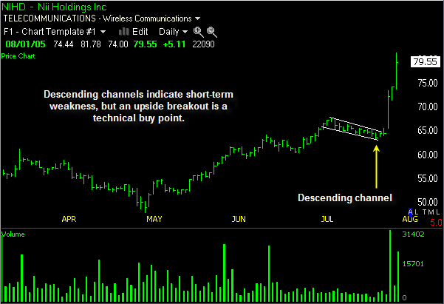

## Ascending Channel – Rising Channel

http://0.gravatar.com/avatar/0e35ab35a1e1cd642ca17036956dcc87?s=30&d=http%3A%2F%2F0.gravatar.com%2Favatar%2Fad516503a11cd5ca435acc9bb6523536%3Fs%3D30&r=G

Ascending channel patterns or rising channels are short-term bullish in that a stock moves higher within an ascending channel, but these patterns often form within longer-term downtrends as continuation patterns.  The ascending channel pattern is often followed by lower prices, but only after a downside penetration of the lower trend line.  The stock will continue channeling upward until it is able to break either the upper or lower trend line.  An upside break is bullish, while a downside break is bearish.

Context:  Often found within a [**downtrend**](http://thestockbandit.com/downtrend-stock/), but a close look reveals a minor uptrend.

Appearance:  This is a [**channeling stock**](http://thestockbandit.com/channeling-stock/) with an upward tilt.  The stock’s price action is controlled by two parallel trend lines.  Below the stock is the primary ascending trend line which connects consecutive higher lows.  Above the stock is a secondary trend line, which also is ascending as it connects consecutive higher highs.  Price follows the path of least resistance in an ascending channel, which is up.  Upon reaching the lower trend line, the stock bounces until it reaches the upper trend line, which acts as [**resistance**](http://thestockbandit.com/support-resistance/) as well as a profit-taking zone.  Trading an ascending channel in the most effective way is through buying dips to the lower trend line for short-term bounce plays, or by waiting for a downside breakout to occur before [**short selling**](http://thestockbandit.com/short-selling/).

Breakout Expectation:  Channeling stocks within ascending channels are only able to reverse course with a downside penetration of the primary ascending trend line.  The intensity of this breakout, the duration of the channel, and the width of the channel will determine how far a breakout may carry.  An upside breakout from an ascending channel indicates a higher intensity of buying, and is a technical buy signal.  A downside breakout from an ascending channel indicates lower prices to come, and is a technical sell signal.

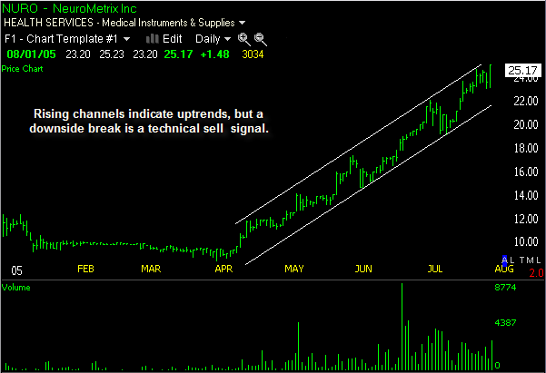

## Rectangle Pattern

http://0.gravatar.com/avatar/0e35ab35a1e1cd642ca17036956dcc87?s=30&d=http%3A%2F%2F0.gravatar.com%2Favatar%2Fad516503a11cd5ca435acc9bb6523536%3Fs%3D30&r=G

A rectangle pattern or box pattern is a trading range which forms as a [**consolidation**](http://thestockbandit.com/consolidation/) phase following a trend, making it a continuation pattern in most cases.  The parallel trend lines connecting multiple highs and lows during this extended period give the pattern its rectangle shape.  A breakout occurs when either trend line is penetrated and the trading range is broken.  An upside breakout from a rectangle pattern following an uptrend is a continuation signal for higher prices and is a technical buy signal.  A downside breakout from a rectangle pattern following a downtrend is a continuation signal for lower prices and is a technical sell signal.

Context:  Rectangle patterns as continuation patterns require a trend which is followed by narrow price action within a trading range.  The trading range is defined by two parallel trend lines which are horizontal and indicate the presence of [**support and resistance**](http://thestockbandit.com/support-resistance/).

Appearance:  This is a [**channeling stock**](http://thestockbandit.com/channeling-stock/) with no tilt.  The stock’s price action is contained by two parallel trend lines.  Price is prevented from achieving new relative highs due to the presence of sellers at higher prices, while also being prevented from making new relative lows due to the presence of buyers at lower prices.  This forms a narrow trading range for at least a few weeks, during which time the stock is only able to move horizontally.  A price penetration of either trend line, ideally on expanding volume, is required to complete this pattern.

Breakout Expectation:  A rectangle pattern breakout can be expected to achieve the equivalent of the height of the rectangle added to the breakout level.

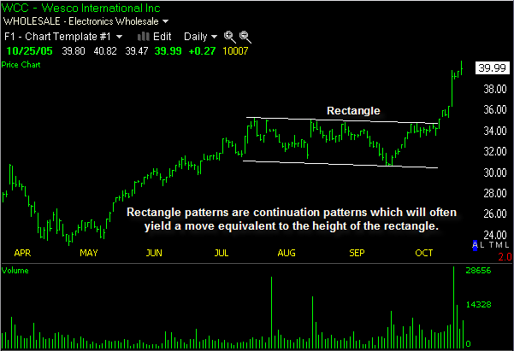

## [Wedge chart pattern](http://www.investopedia.com/terms/w/wedge.asp)

The [wedge chart pattern](http://www.investopedia.com/terms/w/wedge.asp) signals a reverse of the trend that is currently formed within the wedge itself. Wedges are similar in construction to a symmetrical [triangle](http://www.investopedia.com/terms/s/symmetricaltriangle.asp) in that there are two [trendlines](http://www.investopedia.com/terms/t/trendline.asp) - [support](http://www.investopedia.com/terms/s/support.asp) and [resistance](http://www.investopedia.com/terms/r/resistance.asp) - which band the price of a security.   
  
The wedge pattern differs in that it is generally a longer-term pattern, usually lasting three to six months. It also has converging trendlines that slant in an either upward or downward direction, which differs from the more uniform trendlines of triangles.   
  
There are two main types of wedges – falling and rising – which differ on the overall slant of the pattern. A falling wedge slopes downward, while a rising wedge slants upward.   
  
**Falling Wedge**The falling wedge is a generally bullish pattern signaling that one will likely see the price break upwards through the wedge and move into an uptrend. The trendlines of this pattern converge, with both being slanted in a downward direction as the price is trading in a downtrend.

|  |
| --- |
| http://i.investopedia.com/inv/articles/site/fallingwedge.gif |
| Figure 1: Falling wedge pattern |

From the above, one can see that a wedge is similar to the [triangles](http://www.investopedia.com/terms/t/triangle.asp), in that the price movement bounces between the two trendlines, which are bounding the price movement.   
  
Another thing to look at in the falling wedge is that the upper (or resistance) trendline should have a sharper slope than the support level in the wedge construction. When the lower (or support) trendline is clearly flatter as the pattern forms, it signals that selling pressure is waning, as sellers have trouble pushing the price down further each time the security is under pressure.

The price movement in the wedge should at minimum test both the support trendline and the resistance trendline twice during the life of the wedge. The more times it tests each level, especially on the resistance end, the higher quality the wedge pattern is thought to be.   
  
The buy signal is formed when the price breaks through the upper resistance line. This breakout move should be on heavier volume, but due to the longer-term nature of this pattern, it's important that the price has successive closes above the resistance line.   
  
**Rising Wedge**Conversely, a rising wedge is a bearish pattern that signals that the security is likely to head in a downward direction. The trendlines of this pattern converge, with both trendlines slanted in an upward direction.

|  |
| --- |
| http://i.investopedia.com/inv/articles/site/RisingWedge.gif |
| Figure 2: Rising wedge pattern |

Again, the price movement is bounded by the two converging trendlines. As the price moves towards the apex of the pattern, momentum is weakening. A move below the lower support would be viewed by traders as a reversal in the upward trend.   
  
As the strength of the buyers weakens (exhibited by their inability to take the price higher), the sellers start to gain momentum. The pattern is complete, with the sellers taking control of the security, when the price falls below the supporting trendline.

## References

1. <https://thestockbandit.com/chart-patterns/>
2. <http://www.stocktradingtogo.com/2009/05/18/best-stock-chart-patterns-investing-technical-analysis/>
3. <http://www.investopedia.com/university/charts/>
4. [http://www.chartpatterns.com/](http://www.chartpatterns.com/descendingtriangles.htm)